**6**. CREATE TABLE Patients

(

ID INT IDENTITY(1,1),

FirstName NVARCHAR(25),

LastName NVARCHAR(25),

SSN uniqueidentifier DEFAULT NEWID(),

Email AS (UPPER(LEFT(FirstName, 1)) + LOWER(LEFT(LastName, 3) + '@mail.com')),

Temp FLOAT,

CreatedDate DATE

)

SELECT *

FROM Patients

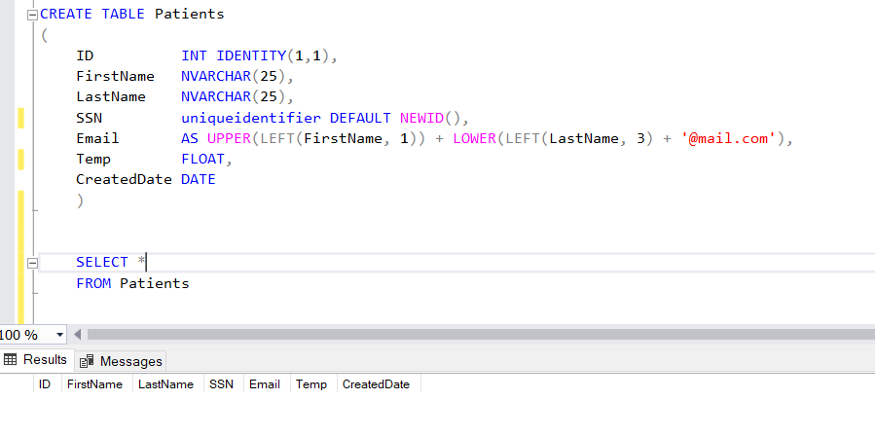

**7.** INSERT INTO Patients (FirstName, LastName, Temp, CreatedDate)

VALUES ('Thomas','Walker','36.6', '2022-09-15'),

('Mary','Smith','37.2', '2022-09-16'),

('Jacob', 'Miller','36.9', '2022-09-17')

SELECT *

FROM Patients

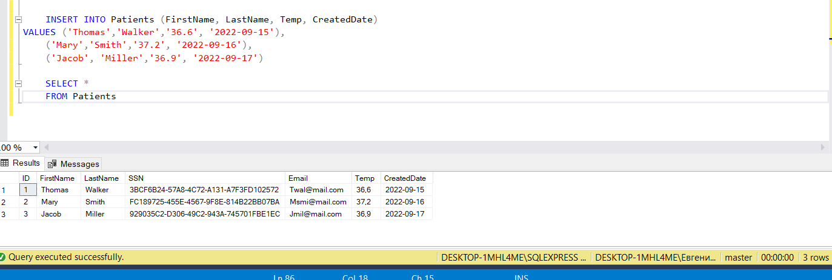

**8.** ALTER TABLE Patients

ADD TempType AS (CASE WHEN Temp > 37 THEN '> 37°C' WHEN Temp < 37 THEN '< 37°C' END)

SELECT *

FROM Patients

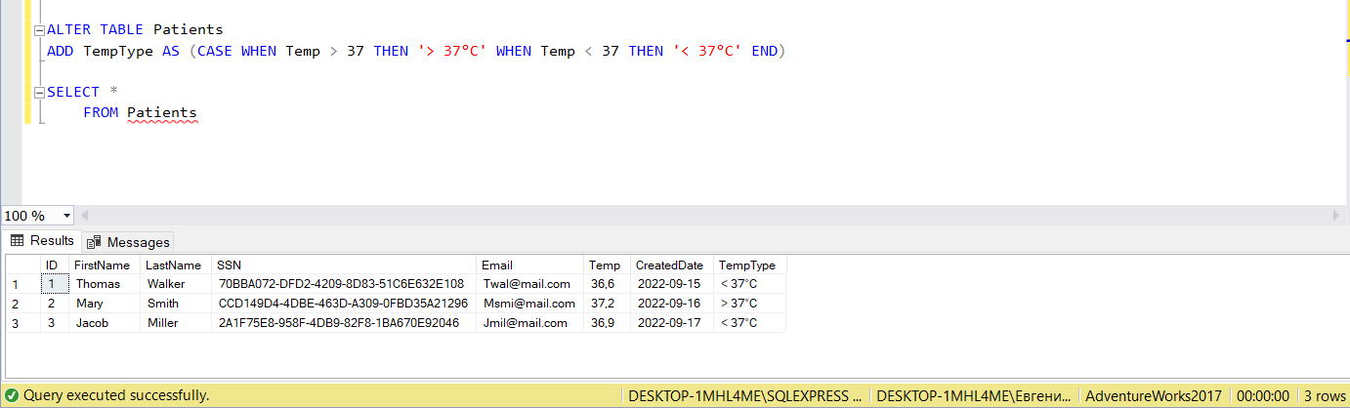

**9.** CREATE VIEW Patients_v

AS

SELECT [ID], [FirstName], [LastName], [SSN], [Email], [Temp]*9/5+32 AS TEMP_Far, [CreatedDate]

FROM [dbo].[Patients]

SELECT *

FROM Patients_v

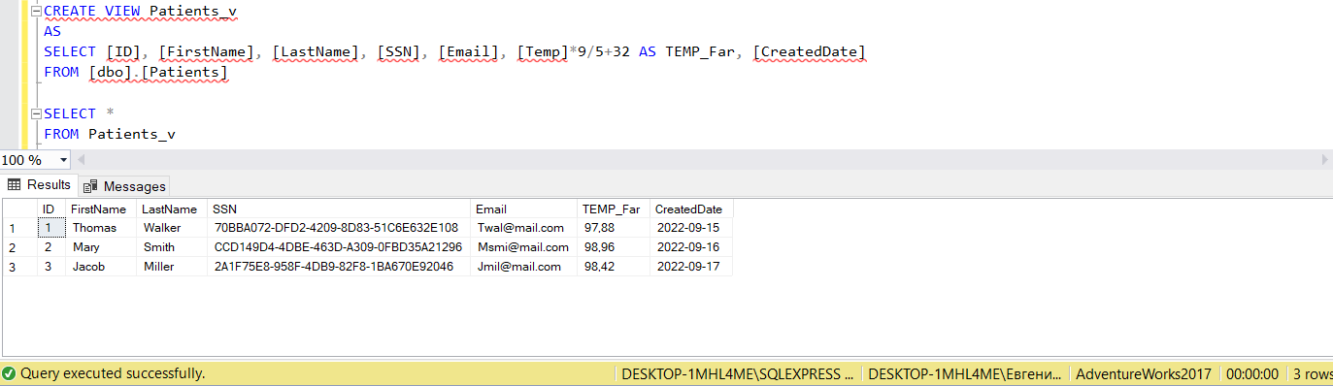

**10.** CREATE FUNCTION dbo.udfCelsFar (@Temp FLOAT)

RETURNS FLOAT

AS

BEGIN

RETURN @Temp*9/5+32

END

SELECT dbo.udfCelsFar (37) Cels_Far

